Biographies

Pamela Combs, is a nationally and internationally recognized public speaker and lecturer, having presented in Europe, Asia, and much of the contiguous United States. She is a Certified Nurse Practitioner having received both her bachelor’s degree and master’s degree from Kent State University. Ms. Combs completed her Clinical Doctor of Nursing Practice degree at Case Western Reserve University in November of 2018. Her doctoral studies focused on Type 1 Diabetes self-management in the acute care setting, a topic about which she remains enthusiastic and continues to advocate for this population of patients. She currently holds the position of Director of the Howley ASPIRE program, an enrichment program at Cleveland Clinic (CC) for high school students interested in a healthcare career. Dr. Combs previously held the position of Chair of the CC Advanced Practice Nursing (APN) council’s subcommittee for Professional Development and is the founder and pioneer of the APN council’s groundbreaking Professional Development Pathways program. The success of this program has had an enterprise-wide impact at the Cleveland Clinic and has thus garnered the attention of executive leaders, both locally and nationally. Besides her clinical and administrative work, Dr. Combs is an advocate for community development and domestic violence awareness.

David Copsey is the lead Respiratory Therapy educator for the Howley ASPIRE Pathways program at the Cleveland Clinic Foundation. In addition to his educational role, he works in the cardiovascular institute as well as the emergency department at Cleveland Clinic Main Campus as a Registered Respiratory Therapis. He has been a Respiratory Therapist for five years and has been serving the Cleveland Clinic patient population for eight years. David has a passion for education and teaching world class care to high school age students. In addition, he also loves taking care of his patients and is very proud of his profession. He received his Associates of Applied Science in Respiratory Therapy in 2021 and then a year later his Bachelor of Respiratory Care from Bowling Green State University. Currently, he is working on his Master of Business Administration and Master of Healthcare Administration from the University of Pheonix.

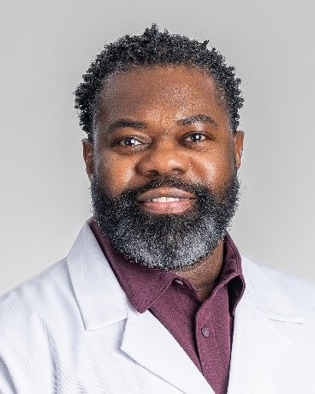

Michael Moreland is a Nursing Professional Development Specialist for the Howley ASPIRE Nurse Scholars Program who joined the team in June of 2023. Nurse Moreland began working for the Cleveland Clinic in 2004 as a licensed practical nurse on an acute care unit at Hillcrest Hospital. He attended Huron School of Nursing and graduated from the LPN-to Registered Nurse program in 2009. Michael later earned his Bachelor of Science in nursing degree in 2019 from Ohio University. His nursing focus while at Hillcrest Hospital was in critical care in the open heart and vascular intensive care unit from 2010 until joining the Howley ASPIRE Program in 2023. Currently, Michael focuses on curriculum development and delivery for this pipeline program, which aims to broaden the knowledge base of nursing for high school students looking to pursue a career in the nursing field.